**NZISM Hawkes Bay Branch Report for 2022**

2021 was another year in which we started with great intentions but ended up with heavy COVID-19 related interruptions. Because of this we weren’t able to host many face-to-face gatherings.

We did manage to host two branch meetings, one in February and one in August which included the AGM. We also hosted a few coffee networking sessions but were hampered by COVID-19 restrictions. It was good to connect where we were able to.

2022 has had a delayed start for our branch but it was great to see new and old faces at our first face to face social network evening and at our recent AGM.

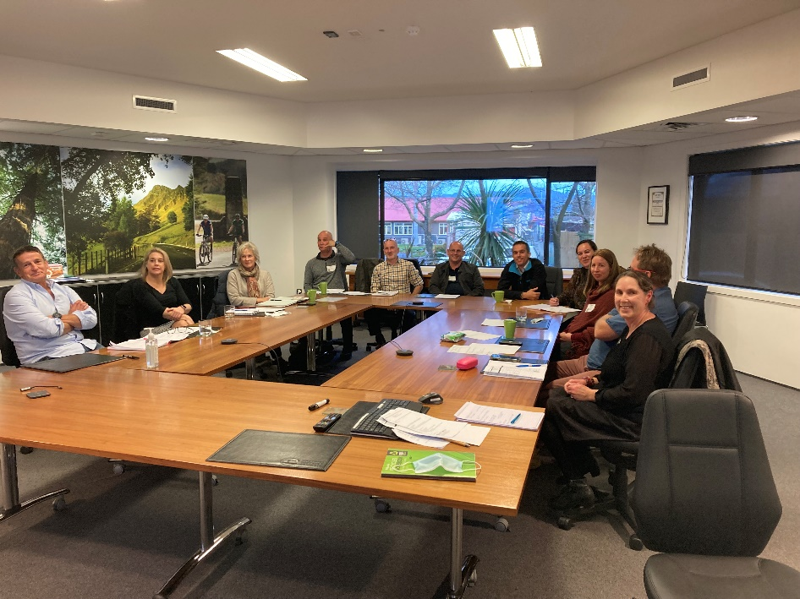

As far as branch membership goes we remain steady with 76 Branch members which is about the same numbers as the previous two years.

I would like to thank our committee members: Amy Harris, Angela Blom, Dan Davis, Joanne Graham, Nikola Bass and Scotty Watson who are all remaining on the committee this year.

On behalf of the committee, I can advise we have been working on planning calendar items for the year and aiming to host a CPD day in October. We look forward to reconnecting with the branch this year

Regards

Jennie Kuzman

Branch Manager – Hawkes Bay